Analyzing Weather Data for Station AL007: Precipitation, Temperature, and Pressure Trends

Abstract
Abstract:
In 2013, the highest recorded precipitation at station AL007 was observed in August, with a maximum of 26.8 mm. During the same year, an analysis of the monthly minimum temperatures revealed that none fell below 0°C. Additionally, in 2014, the atmospheric pressure at station AL007 varied with a maximum of 1031.99 mbar in December and a minimum of 988.17 mbar in March, resulting in a difference of 43.82 mbar. Overall, the data indicate significant variability in both temperature and pressure across different months, highlighting the dynamic nature of the weather patterns at this location.
Keywords: Precipitation, Temperature, Pressure, Station AL007

Precipitation

In which month of the year 2013 was the highest value of the precipitation recorded for station AL007?
To determine the month in 2013 with the highest value of precipitation recorded for station AL007, we'll examine the "Max Precipitation (mm)" data for each month of that year.
Data:
Month | Max Precipitation (mm)
January | 5.1
February | 5.8
March | 11.9
April | 6.5
May | 9.1
June | 4.8
July | 13.4
August | 26.8
September | 10.2
November | 21.5
December | 2.5
Calculations:
- Compare the values in the "Max Precipitation (mm)" column to find the highest.
Conclusion:
The highest value of precipitation recorded for station AL007 in 2013 was in August, with a maximum precipitation of 26.8 mm.

Data Charts
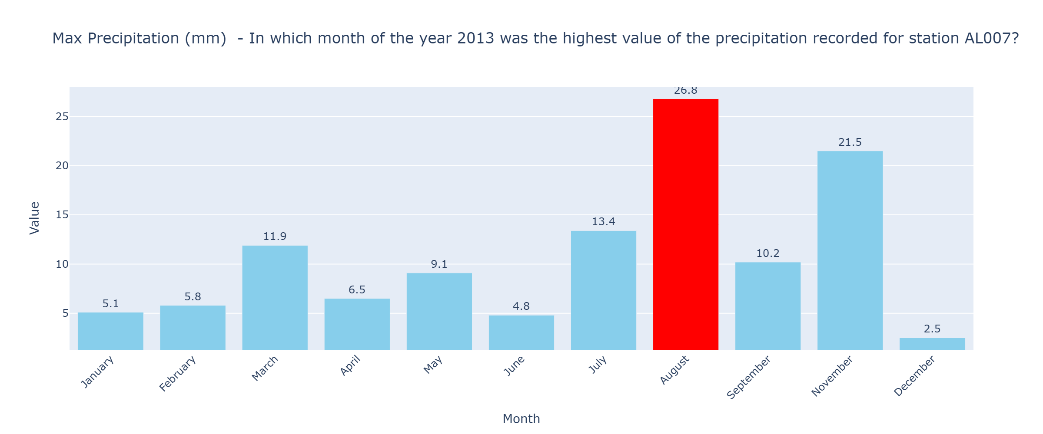

Temperature

How many times did the temperature drop below value 0 at station AL007 in year 2015?
To determine how many times the temperature dropped below 0°C at station AL007 in the year 2015, we need to look at the minimum temperature values for each month in 2015. The minimum temperature indicates the lowest temperature recorded during each month.
Data:
Month | Min Temperature (°C)
January | 1.366
February | 1.922
March | 5.219
April | 5.237
May | 11.182
June | 16.541
July | 21.232
August | 18.28
September | 13.602
October | 10.06
November | 4.251
December | 0.893
Calculations:
- Review the minimum temperature values for each month.
- Check if any of the minimum temperature values are below 0°C.
Conclusion:
- None of the minimum temperature values for each month in 2015 are below 0°C.
Therefore, the temperature did not drop below 0°C at station AL007 in the year 2015.

Pressure

By how much do the maximum and minimum values of the pressure differ in year 2014 for station AL007?
To determine the difference between the maximum and minimum values of the pressure for station AL007 in the year 2014, we will use the relevant atmospheric pressure data.
Data:
Month | Max Pressure (mbar) | Min Pressure (mbar)
January | 1029.13 | 995.54
February | 1022.76 | 1003.23
March | 1028.87 | 988.17
April | 1021.1 | 1000.12
May | 1021.78 | 1002.14
June | 1022.32 | 1007.71
July | 1023.3 | 1004.48
August | 1017.3 | 1008.48
September | 1028.51 | 1002.38
October | 1025.86 | 1003.34
November | 1026.91 | 1004.33
December | 1031.99 | 996.25
Calculations:
1. Find the maximum value of the pressure for the year 2014:
- From the table, the maximum pressure value is 1031.99 mbar in December.
2. Find the minimum value of the pressure for the year 2014:
- From the table, the minimum pressure value is 988.17 mbar in March.
3. Calculate the difference between the maximum and minimum pressures:
- Difference = Max Pressure - Min Pressure
- Difference = 1031.99 mbar - 988.17 mbar = 43.82 mbar
Conclusion:
The difference between the maximum and minimum values of the pressure for station AL007 in the year 2014 is 43.82 mbar.

Data Charts
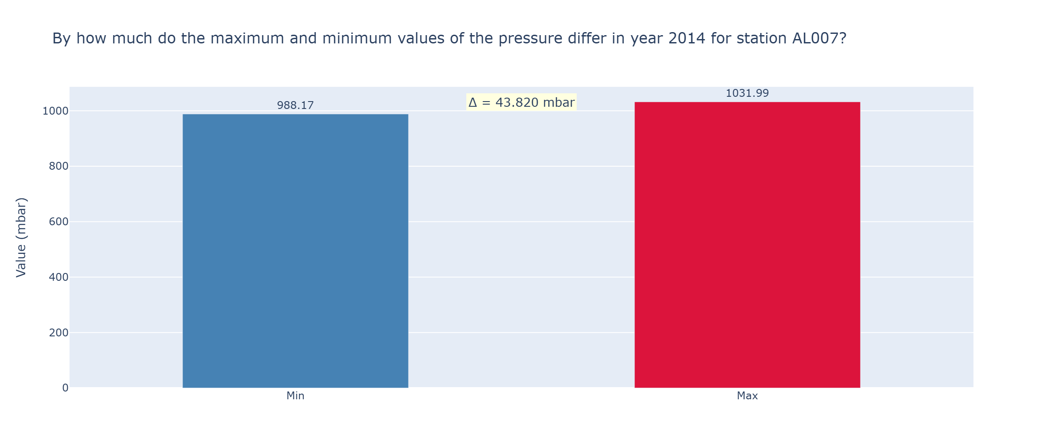

Data
Summary Table:
Question | Numerical Data
highest precipitation | August,26.8 mm
temperature below 0°C | 0 times in 2015
pressure difference | 2014,43.82 mbar

Conclusion
Based on the analysis provided, it is evident that various atmospheric conditions were consistently monitored at station AL007 across different years. In 2013, August recorded the highest precipitation with a value of 26.8 mm, indicating significant rainfall during that month. In 2015, the temperature did not drop below 0°C, suggesting milder winter conditions that year. Furthermore, the year 2014 saw a notable pressure difference of 43.82 mbar between the maximum and minimum recorded values, highlighting variability in atmospheric pressure. These insights offer a comprehensive understanding of climatic patterns at station AL007 and can be instrumental for future meteorological assessments.

